November 10, 2004

His Excellency Ayatollah Mahmoud Hashemi Shahrudi
Judiciary chief
Ministry of Justice
Park-e Shahr
Tehran, Islamic Republic of Iran
Fax: 011 98 21 879 6671 / 011 98 21 640 4018/4019

Your Excellency:

We are writing on behalf of the International Women’s Media Foundation to condemn the recent arrests of journalists Mahboubeh Abbas-Gholizadeh, editor of Farzaneh magazine, and Fereshteh Ghazi of Etemad newspaper.

According to reports from Reporters sans Frontieres, a Paris-based organization that supports press freedom around the world, and The New York Times, both Abbas-Gholizadeh and Ghazi are believed to have been arrested because of their connections with pro-democracy reformist websites. Police detained Abbas-Gholizadeh on November 1, when she returned to Iran after attending the European Social Forum in London. She is currently being held in solitary confinement and is officially accused of “threatening national security.” Ghazi was arrested four days earlier on October 28, and is accused by Iranian authorities of “immoral behavior.”

With the recent blockage of political websites and the wave of arrests of many cyber-journalists in Iran, we are concerned that the arrests of Abbas-Gholizadeh and Ghazi signal more restrictions on free expression and press freedom.

As a network of more than 1,200 women in the media around the world who are supporters of a worldwide free press, we respectfully urge you to use the power of your office to insure that both of these journalists receive a fair hearing. Your Excellency, by using the weight of your office to ensure that justice is done in this case and that both journalists are given the full protection of the law, you will take a strong step toward preserving a free and independent press in Iran.

Thank you for your attention.

Sincerely,

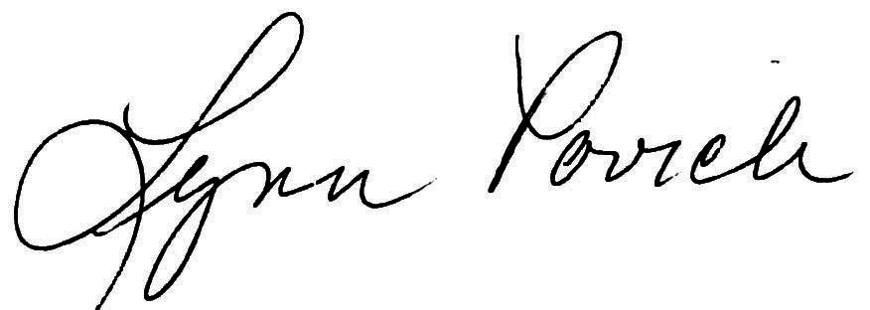

Lynn Povich
Co-Chair
IWMF

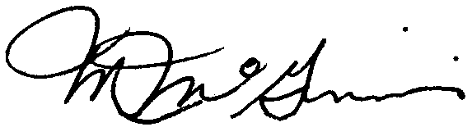

Marcy McGinnis
Co-Chair
IWMF

Kerry Smith Marash
Chair,
Press Freedom Task Force

cc: Hojjatoleslam Val moslemin Sayed Khatemi
President of the Islamic Republic of Iran
The Presidency
Palestine Avenue, Azerbaijan intersection
Fax: 98 21 649 58 80, 98 21 64 66 415 / 98 21 67 31 77

